Python实验报告10

学号：117060400212 姓名：张佳奇 班级：应用统计学2班

指导老师:林卫中

实验名称：unit7 exercise

实验题目1：

Ex7.1 Python源文件改写

算法实现：

import keyword

kws = keyword.kwlist

file = input("请输入一个Python源程序文件")

fr = open(file,"r",encoding="utf-8")

wline = ""

for line in fr:

wline += "\n"

if "import" in line:

wline += line

else:

j=0

while line[j] =="":

wline += ""

j += 1

sline = line.split()

for w in sline:

if w in kws:

wline += w

elif "." in w:

wline += w

elif "(" in w:

wline += w

else:

wline += w.upper()

wline += ""

fr.close()

fw = open(file,"w",encoding="utf-8")

fw.write(wline)

fw.close()

实验结果：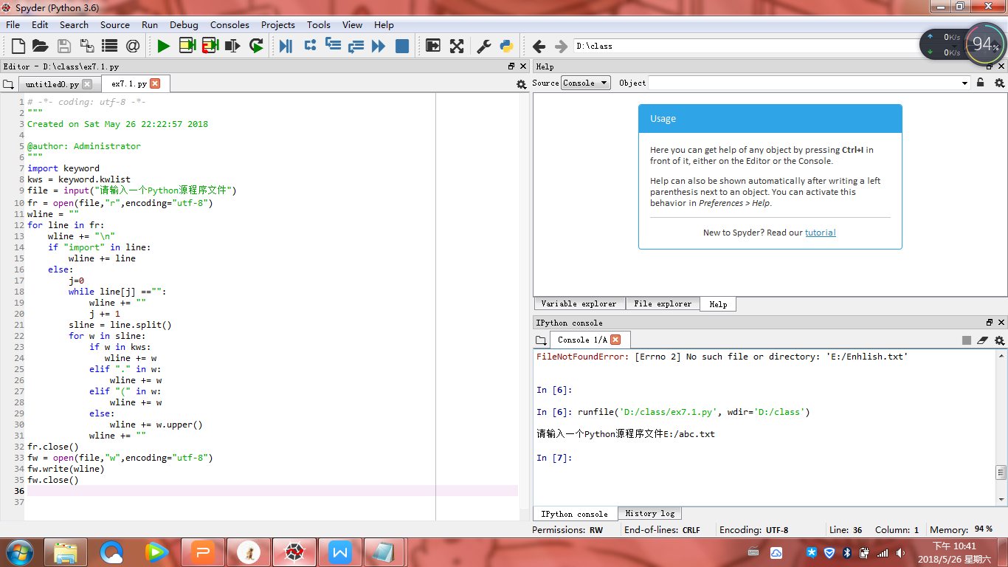

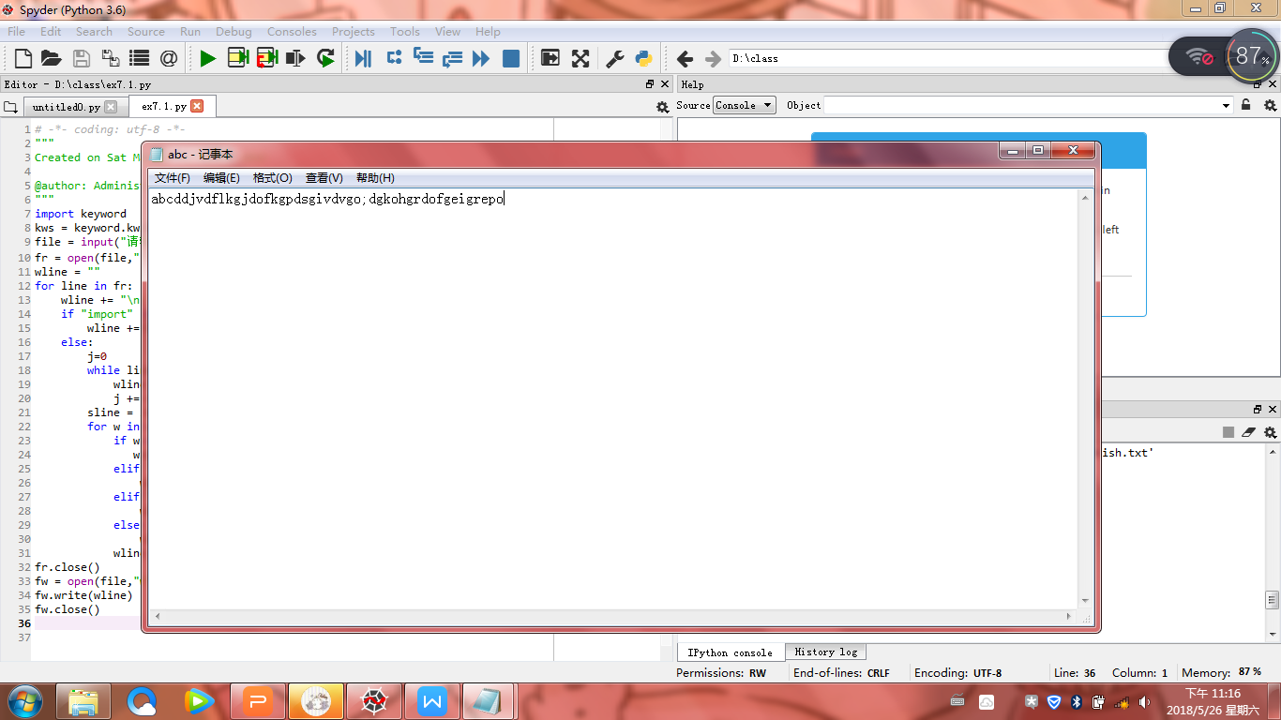

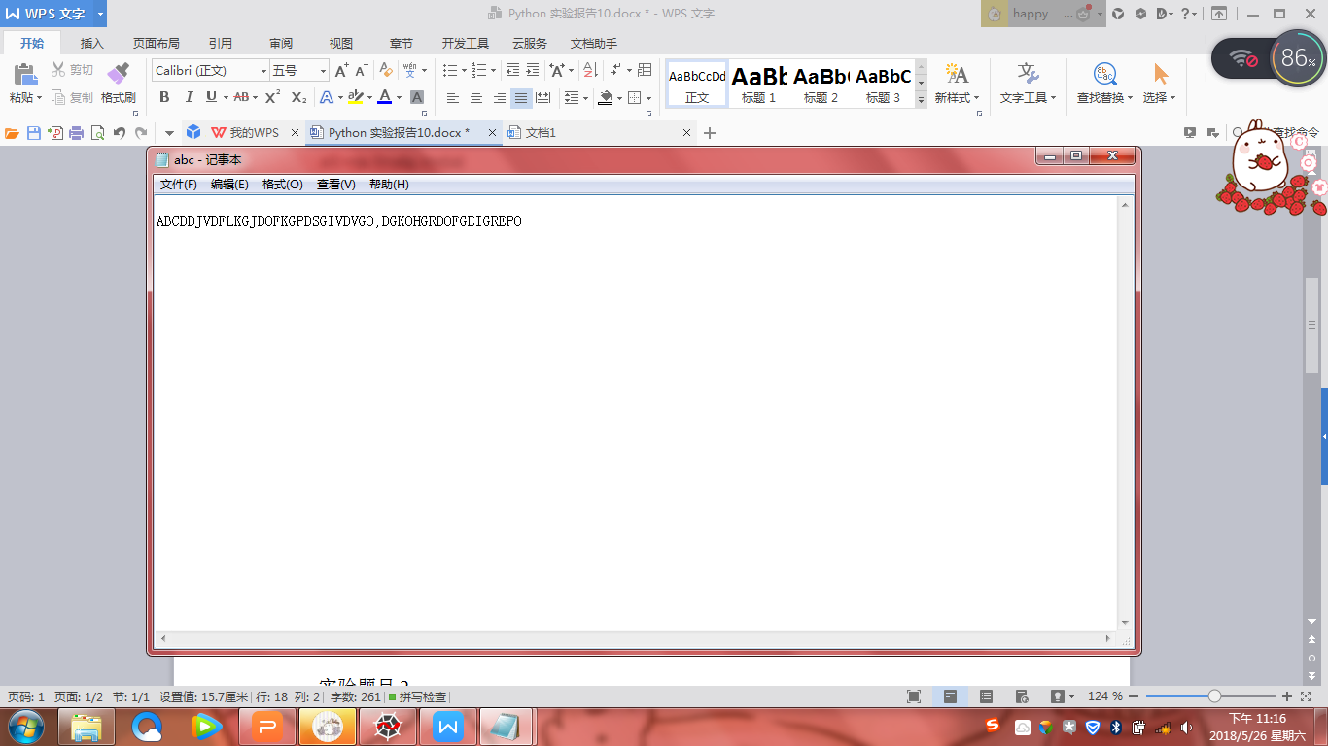

实验题目2：

Ex7.2

算法实现：

7.2.1

from PIL import Image

im = Image.open("123.jpg")

c = 5

w,h = im.size

im2 = Image.open("123.jpg")

im2.resize((w//c,h//c)).save("123.jpg","JPEG")

7.2.2

from PIL import Image

im = Image.open("123.jpg")

c = 5

w,h = im.size

im.thumbnail((w//c,h//c))

im.save("123TN","JPEG")

实验结果：

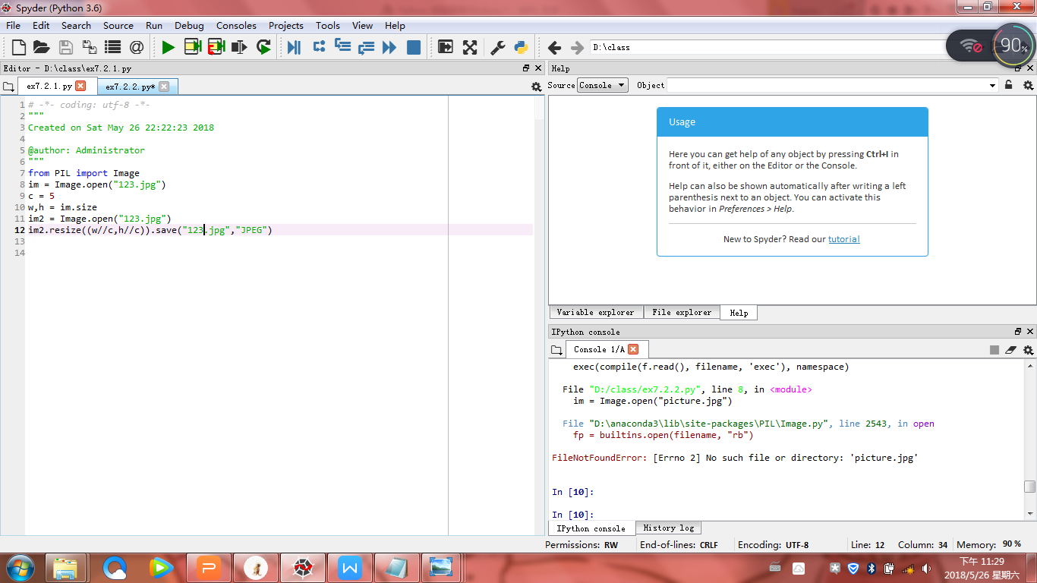

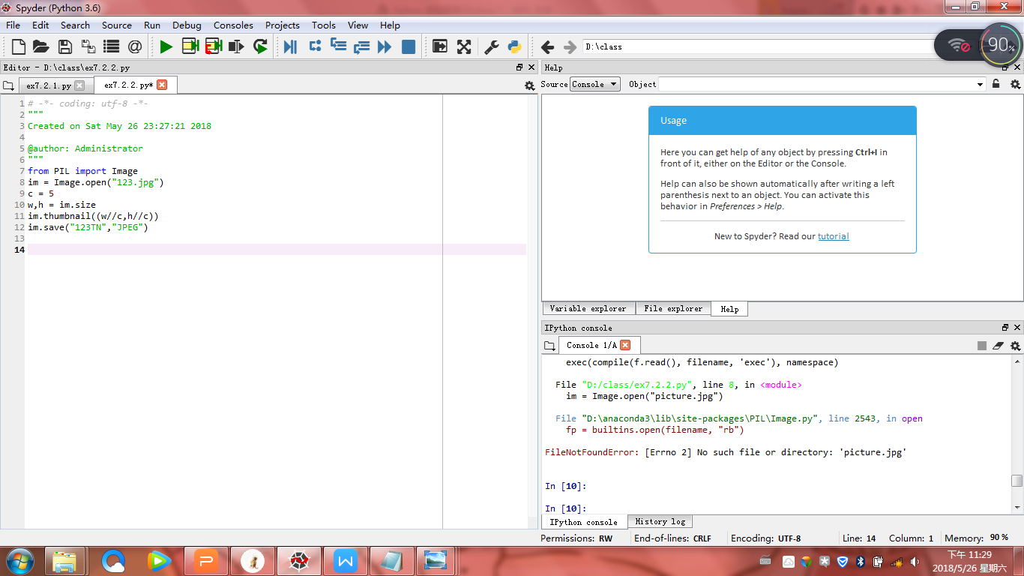



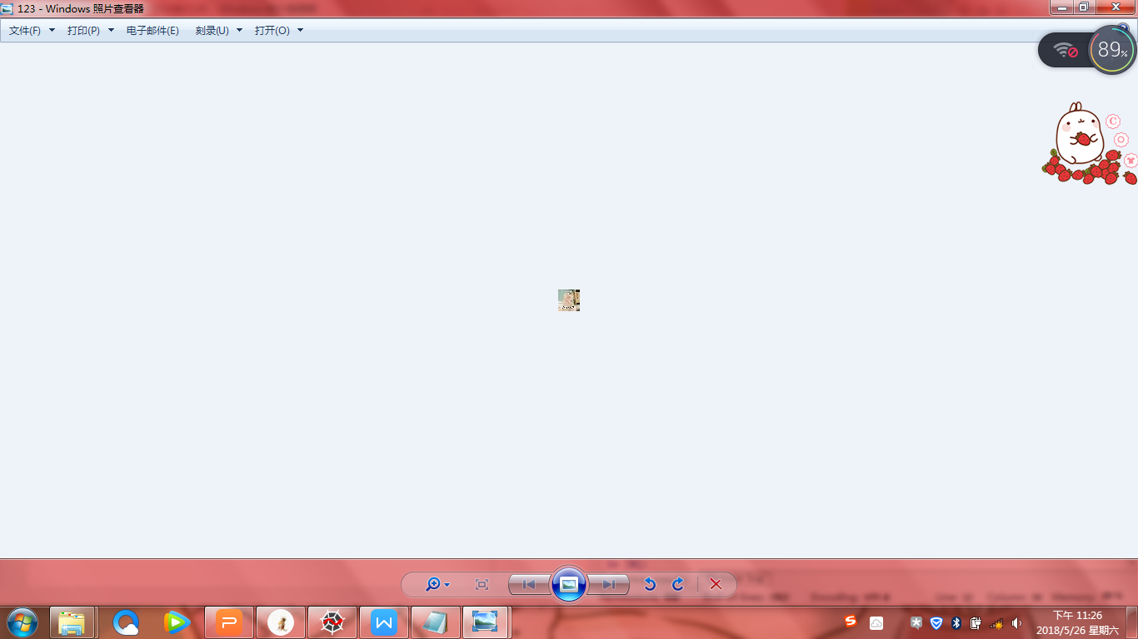

实验题目3：

Ex7.5 制作英文学习词典

算法实现：

import os

def userOperateInterface():

print("\n请选择词典功能")

print("i:添加单词")

print("s:查询单词")

print("Q:退出词典")

print("请选择功能")

return input()

def addWord(wordDict:dict,fileName):

str = input("您输入要加入的单词")

if str in wordDict.keys():

print("该单词已添加到字典库\n")

userOperateInterface()

else:

t = input("请输入此单词的中文释义")

wordDict[str] = t

with open(fileName,"a") as fw:

fw.write(str + " "+t+"\n")

def selectWord(wordDict:dict):

str = input("请输入您要查询的单词:")

if str not in wordDict.keys():

print("字典中未找到这个单词\n")

else:

print(wordDict[str])

def main():

wordDict={}

if os.path.exists("dict.txt"):

with open("dict.txt","r") as fr:

for In in fr:

s=In.split("")

wordDict[s[0]] = s[1]

else:

fw = open("dict.txt","w")

fw.close()

print("\*\*\*\*\*\*欢迎使用简明英汉字典\*\*\*\*\*\*")

while True:

op = userOperateInterface()

if op =="i":

addWord(wordDict,"dict.txt")

elif op =="s":

selectWord(wordDict)

elif op=="Q":

break

else:

print("输入有误\n")

main()

实验结果：

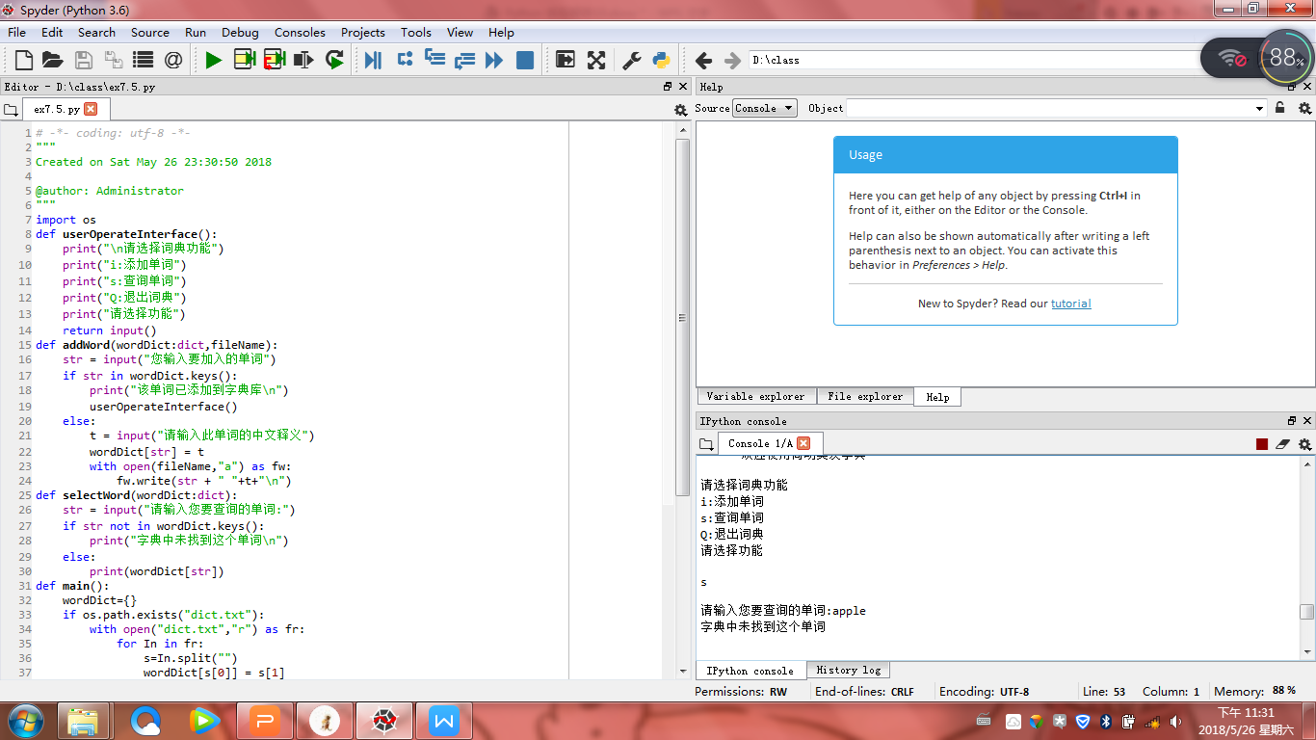

小结：这节课题比较少，但可能时间长没上课，有点手生，还是要加强课下的学习。在做7.5时，特别费力。可以说是迄今为止最长的代码了，感觉，看到这么长的就比较害怕，还要加油呢！！